|  |  |  |  |  |  |
| --- | --- | --- | --- | --- | --- |
| Date | 12-Dec-22 | | | Tester Name | Mayuri Patel |
| Environment | Penfax - Test | | | Login used |  |
| Operating System | Select OS | Version: | Update: | | |
| Software Used | Select Software | Version: | Update: | | |
| Select Software | Version: | Update: | | |
| Release version | 22.4.1 | | | | |
| Title | E15 Reports | | | | |
| Test Type | Regression | | | | |
| Test Scenario | E15.06 Process Trial Balance Report | | | | |
|  |  | | | | |
| Expected Results | Report should be validated against member’s account and PEPP Valuation Report. | | | | |
| Pass/Fail | Pass | | | JIRA# |  |

Describe your steps with screenshots:

1. Log into Penfax. Go to Batches -> Batch Processes. Select PEPP Trial Balance Report from the dropdown. Click on Search.

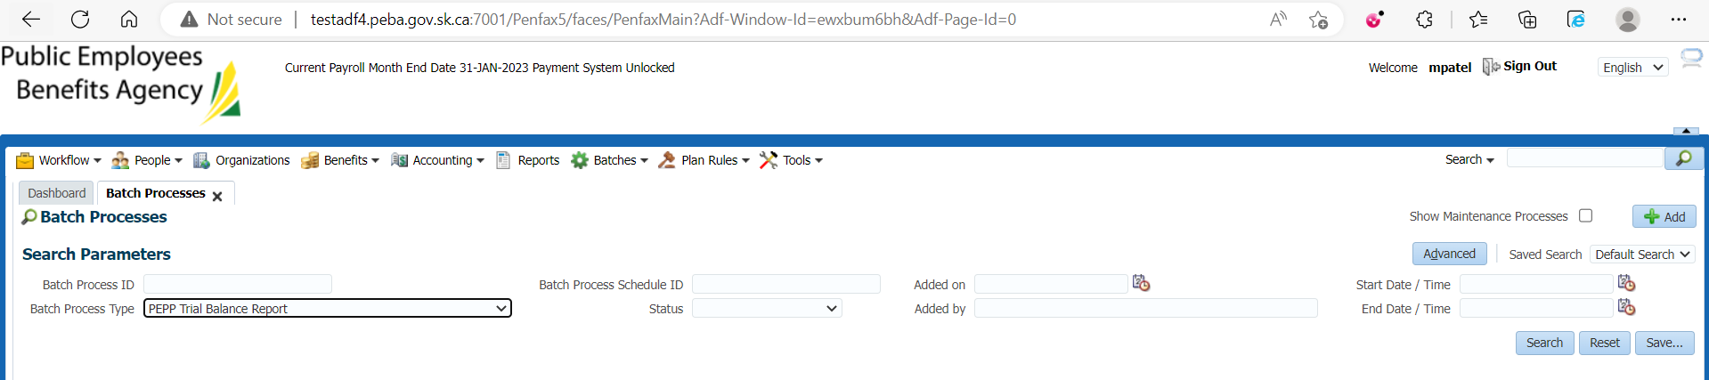

1. This batch is scheduled to run every day at 9 pm. Click on the first Batch Process ID.

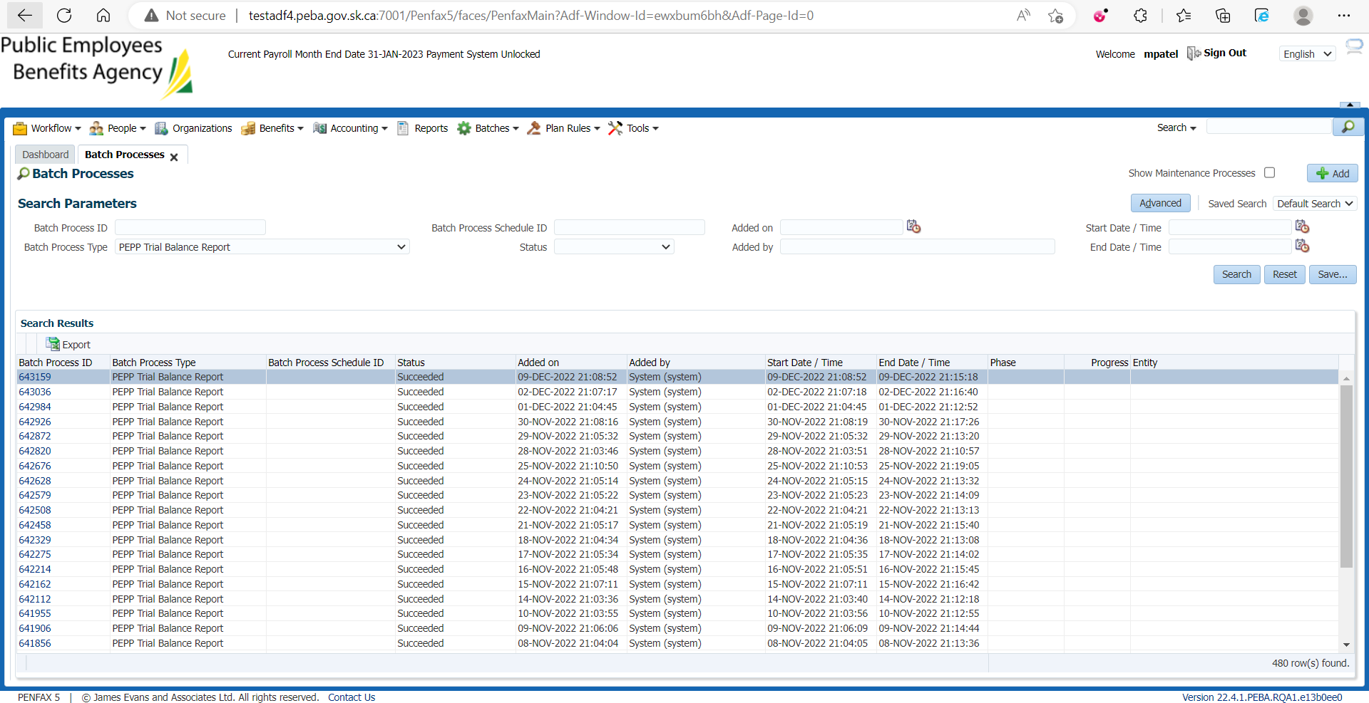

1. Go to Files tab. There are 2 reports – Trial Balance by Member in excel format and Trial Balance in PDF format.

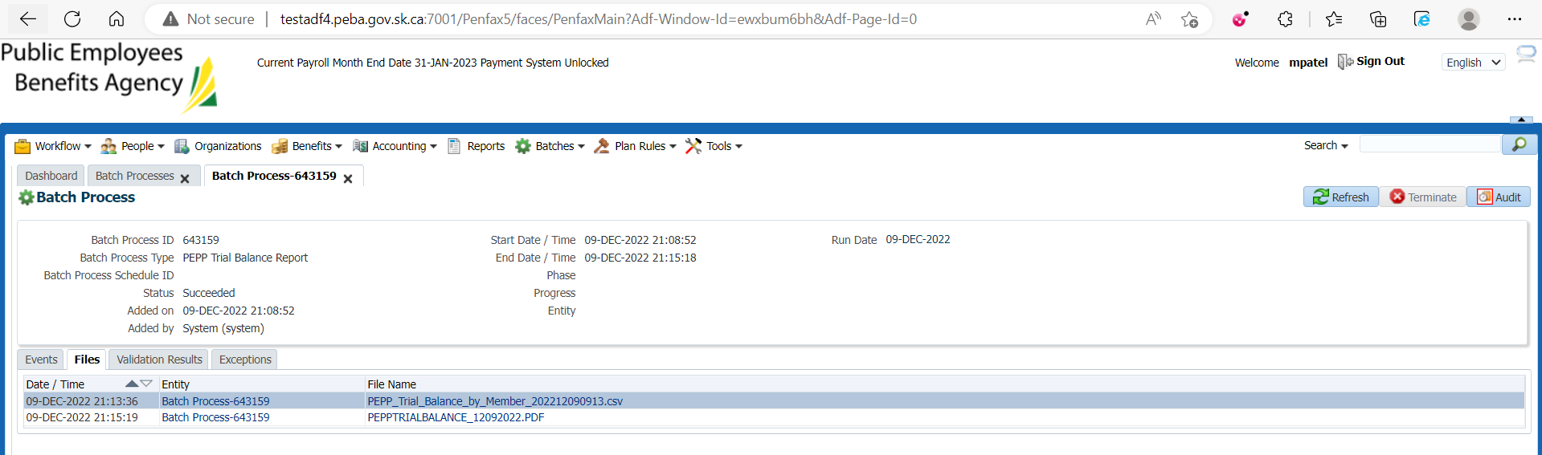

1. Open the PEPP Trial Balance by Member report.

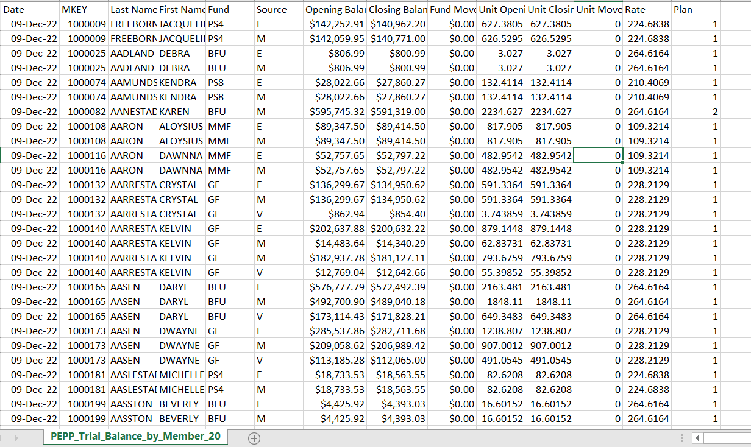

Validate MKey:

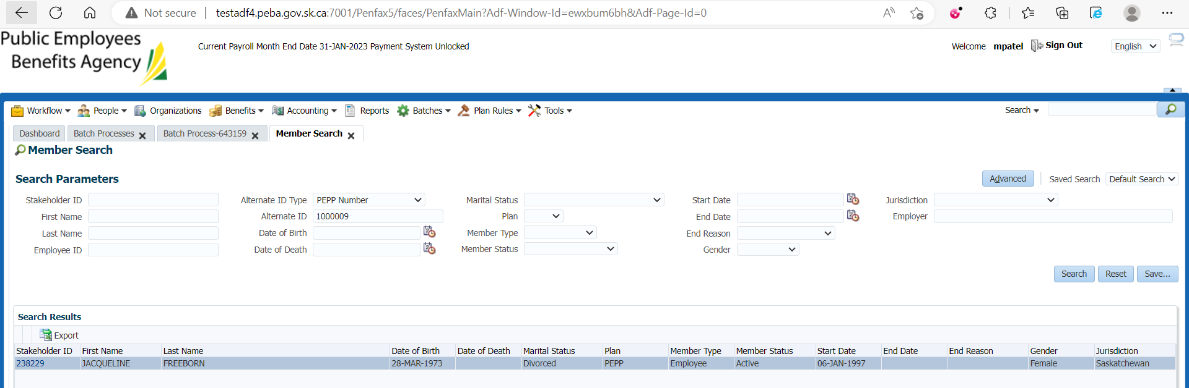

Validate opening and closing balance and units:

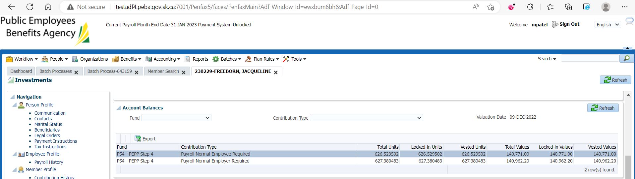

1. Open the PEPP Trial Balance report.

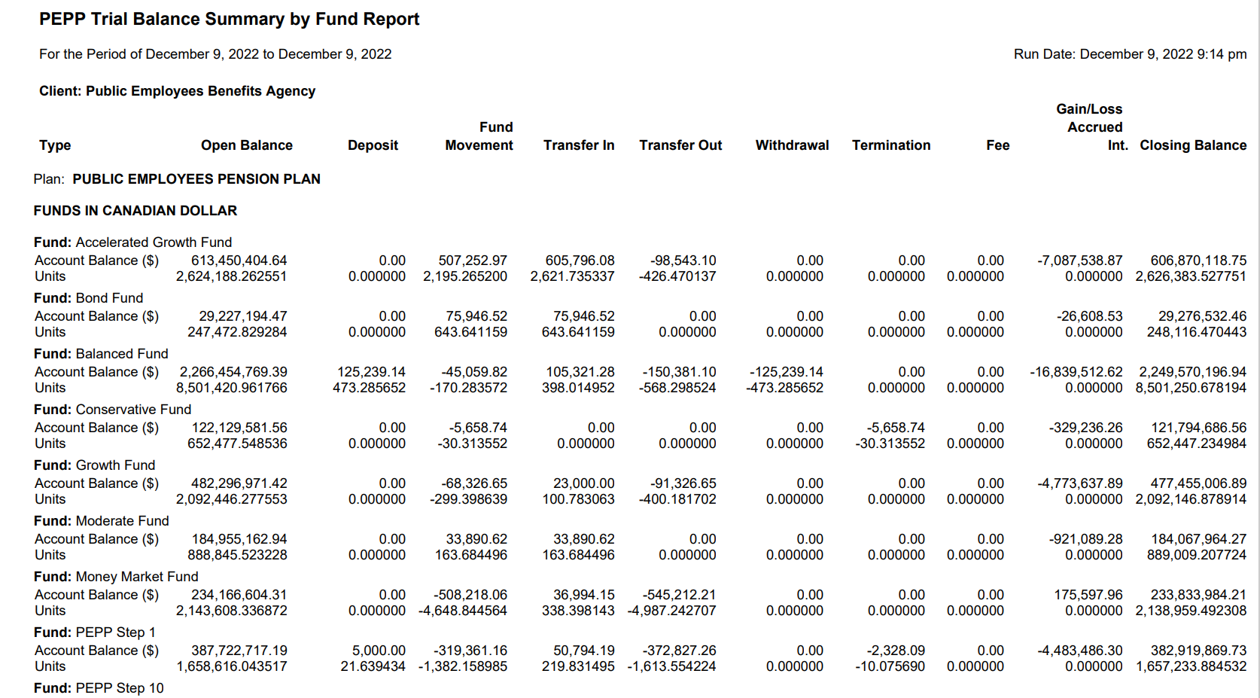

Open PEPP Valuation Report and validate the funds against PEPP Trial Balance Report.

